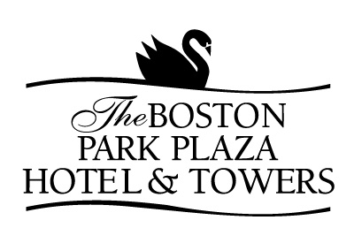

AFTERNOON BREAKS

(Maximum duration of 30 minutes)

FENWAY PARK

Warm Popcorn, Crackerjacks and Soft Pretzels with Mustard
Corn Dogs on a Stick
Bags of Peanuts
Ice Cream Sandwiches
O’Doul’s Non Alcohol Brew and Assorted Soft Drinks
$12.00 per Guest 

AFTERNOON TEA

Assorted Finger Sandwiches
With Roast Beef, Turkey, Ham and Cucumber
Fresh Scones and Assorted Petit Fours
Whipped Cream, Warm Marmalade, Sweet Butter
Tea and Iced Tea
$12.50 per Guest 

COOKIES AND MILK

Chocolate Chip Cookies,
White Chocolate and Macadamia Nut Cookies,
Raisin-Oatmeal Cookies and Almond Biscotti
Chocolate and Whole Milk
Freshly Brewed Regular and Decaffeinated Coffee and Tea
$9.00 per Guest 

STRAWBERRY FIELDS
Chocolate Dipped Strawberries
Display of Seasonal Fresh Fruits
Sliced Pound Cake
Whipped Cream
Bottled Juices and Assorted Soft Drinks
$13.50 per Guest 

AFTERNOON BREAKS

(Maximum duration of 30 minutes)

APPLE HARVEST
Whole Seasonal Apples
Apple Turnovers
Apple-Cinnamon Muffins
Granola Bars
Nantucket Nectars, Assorted Soft Drinks and Mineral Waters
$8.50 per Guest 

I SCREAM, YOU SCREAM

Assorted Ben and Jerry’s Ice Cream Bars
Frozen Yogurt Bars
Italian Ices
Vanilla and Chocolate Bon Bons
Coca-Cola and Root Beer Floats
Assorted Soft Drinks and Mineral Waters
$12.00 per Guest 

AT THE MOVIES

Soft Pretzels with Yellow Mustard
Bags of Popcorn and Potato Chips
Licorice Sticks, Milk Duds, M&M’s,
Snow Caps and Good N’Plenty
Nantucket Nectars, Assorted Soft Drinks and Mineral Waters
$14.00 per Guest 

