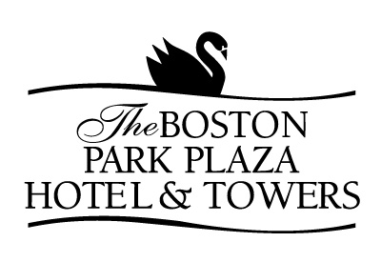

(Minimum of 25 guests)
BUFFET LUNCHEON
A $5.00 per person charge will apply for groups of less than 25 Guests

BUFFET #1

Deli Platter or Deli Wraps
Soup du Jour

Spring Greens and Julienne Vegetables, Honey Mustard Dressing
Country Style Potato Salad
Fresh Fruit Salad

Roasted Turkey, Black Forest Ham, Genoa Salami, Rare Roast Beef
Provolone, Cheddar and Havarti Cheeses
Garden Tomatoes, Lettuce, Dill Pickles and Pitted Olives
Assorted Rolls and Breads

Individual Fruit Tarts
Freshly Brewed Coffee, Decaffeinated Coffee and Tea
$32.00 per Guest 

BUFFET #2

Hot Buffet
Soup du Jour

Spring Greens and Julienne Vegetables, Honey Mustard Dressing
Sliced Seasonal Fruit Display

(Select Two Entrees)
Boston Baked Scrod, Lemon Thyme Butter Sauce
Orzo and Olive Chicken Breast, Mustard Dill Sauce
Old-Fashioned Pot Roast, Mushroom Sauce
Mushroom Triangle Phyllo, Tomato Caper Coulis

Seasonal Garden Vegetables and Starch

Assorted Miniature Pastries
Freshly Brewed Coffee, Decaffeinated Coffee and Tea
$38.00 per Guest 

(Minimum of 25 guests)
BUFFET LUNCHEON
A $5.00 per person charge will apply for groups of less than 25 Guests

BUFFET #3
Italian Style

Roasted Tomato, Basil and Orzo Soup

Antipasto Display of Tomatoes, Buffalo Mozzarella, Olives, Genoa Salami, Marinated Mushrooms and Shaved Parmesan Cheese

Chicken Piccata, Lemon and Caper Sauce
Penne Pasta and Roasted Vegetables, Pesto Cream Sauce
Individual Cheese and Meat Calzones

Vanilla and Chocolate Cannoli and Biscotti
Freshly Brewed Coffee, Decaffeinated Coffee and Tea
$35.00 per Guest 

BUFFET #4
Asian Style

Egg Drop Soup

Cold Sesame Noodles
Vegetarian Egg Rolls

Sweet and Sour Chicken
Ginger Beef with Broccoli
Shrimp Fried Rice
Stir Fried Vegetables

Fortune Cookies and Almond Cookies
Freshly Brewed Coffee, Decaffeinated Coffee and Tea
$35.00 per Guest 

