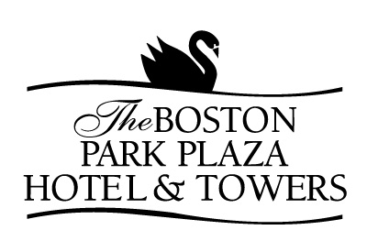

PLAZA BREAKFAST BUFFET

(Minimum of 25 guests)
A $5.00 per person charge will apply for groups of less than 25 Guests

Fresh Orange, Fresh Grapefruit and Cranberry Juice

Sliced Seasonal Fruits and Berries

Assorted Cold Cereals with Whole and Skim Milk

Freshly Baked Mini Muffins, Breakfast Breads and Assorted Bagels
Fruit Preserves, Sweet Butter and Cream Cheese

Scrambled Eggs with Garden Chives and Fresh Herbs

Lyonnaise Potatoes

Hickory Smoked Bacon and Chicken Apple Sausage

Freshly Brewed Regular and Decaffeinated Coffee and Tea

$27.00 per Guest 

ADDITIONAL ITEMS

Smoked Salmon Platter with Capers, Tomatoes and Red Onions
$7.50 per Guest

Omelet Station with Ham, Mushrooms, Onions, Peppers, Tomatoes and Cheese*
$6.00 per Guest

Cheese Blintzes with Fruit Sauce
$5.00 per Guest

French Toast, Pancakes or Waffles with warm Maple Syrup and Fruit Compote
$6.00 per Guest

Ham, Cheese and Egg Croissant Sandwich
$5.00 per Guest

* One Chef at $125.00 required per 75 Guests

