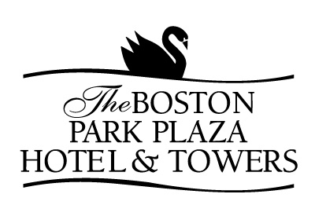

BEVERAGE SERVICE

PREMIUM BRANDS
Absolut Vodka, Tanqueray Gin, Crown Royal Whiskey, Maker’s Mark Bourbon, Chivas Regal Scotch and Bacardi Silver Rum
$14.00 first hour/ $7.00 additional hour(s)

NAME BRANDS
Smirnoff Vodka, Beefeater’s Gin, Seagram’s V.O. Whiskey, Jack Daniels Bourbon, Dewar’s White Label Scotch and Bacardi Light Rum
$12.00 first hour/ $6.00 additional hour(s)

HOST BAR
Premium Brands at $7.00
Name Brands at $6.00
House Red and White Wine at $5.00
Domestic and Non-Alcoholic Beer at $4.50
Imported Beer at $5.00
Mineral Waters/Fruit Juices at $3.75

Soft Drinks at $3.50

MARTINI BAR

Premium and Flavored Vodka and Gin Martinis at $7.00
(Ice Sculptures available upon request)

CASH BAR
Name Brands at $6.50
House Red and White Wine at $5.50
Domestic and Non-Alcoholic Beer at $5.00
Imported Beer at $5.50
Mineral Waters/Fruit Juices at $3.75

Soft Drinks at $3.50

Cordials at $7.00
*Cash Bar Prices include Tax*

Bartender Fee $125.00 per 100 Guests

The Boston Park Plaza Hotel Encourages

Safe and Responsible Alcohol Consumption

